ABSTRACT TEMPLATE FOR HITBASS 2019

First I. Author¹, Second Author²

¹Affiliation for Author I, Province, Country
²Affilitation for Author II, Province, Country

BACKGROUND/OBJECTIVES: This section should include the latest information on the topic and key constructs of interest. Where relevant, a conceptual/theoretical framework undertaken should be explicitly stated. Also, a novelty of the research project should be addressed that goes beyond the statement that “this has not been examined before”. A clear purpose of the study should be presented with respective hypotheses, where relevant.

METHOD: A research design with analysis aligned with the purpose of the project should be explicitly stated. A short description of the procedures/instrumentations should also be provided. The method section should briefly describe the participants and the sampling method involved, if the methodology involved recruitment of subjects.

RESULTS: If desired, the results could be reported using a line or a bar graph, preferably according to the APA formatting style. Aside from the descriptive statistics, if inferential analyses were involved the value of test statistic, degrees of freedom, and effect sizes should be reported.

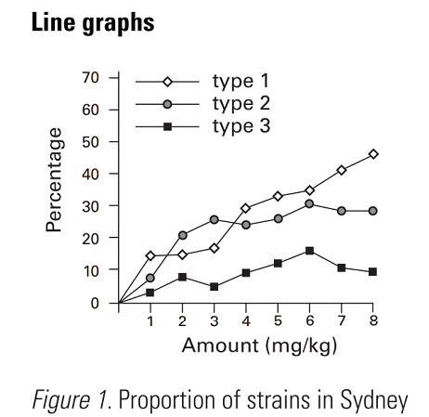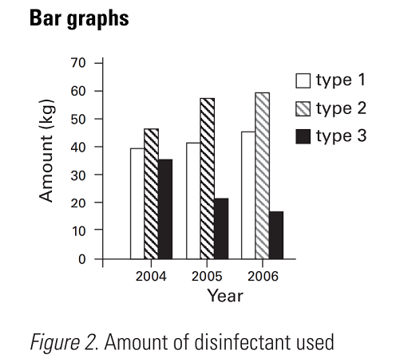

CONCLUSION/IMPLICATION: This section should contain the most important take-home message of the study, expressed in a few precisely worded sentences. A clear practical/clinical relevance should be discussed, and where relevant what the study adds conceptually to the existing knowledge base. Suggestions for future research or a short discussion of the relevant limitations is also valuable.

HITBASS 2019
Presenting Author Details

Last Name

First Name Title

Email

Institution

Department

Mailing Address _______________________________________
_____________________________________________________
_____________________________________________________

Preferred Presentation Type
- Oral
- Poster

Preferred Topical Session
- Digital Health Technologies
- Clinical & Health Research for Well-Being & Human Performance
- Modern Biotechnology
- Bioinformatics​, Imaging and Personalized Health
- Biomechanics

